`MYELOID LEUKEMIA PREDICTION
- INTRODUCTION
Predictive models in healthcare have transformed patient care, enabling more personalized and effective treatment strategies. Accurate prognostic models can significantly impact the quality and timing of treatment decisions, and lead to more efficient resource allocation within healthcare facilities.

Indeed, for blood cancer, patients identified as having a low-risk profile may receive supportive therapies aimed at improving blood counts and overall quality of life, while those identified as high-risk candidates may be prioritized for more intensive treatment options, such as hematopoietic stem cell transplantation.

The goal of this project is to predict the disease risk for patients diagnosed with blood cancer. The risk assessment is measured by overall survival.

- DATA
For this project, the data are from the Institute Gustave Roussy (24 clinical centers).
We have Clinical and Molecular data from 3,323 patients for the training set and 1,193 patients for the test set.
CLINICAL DATA | Normal value | Definition | Interpretation
BM_BLAST | <5% | % of Blasts (= immature blood cells) in the Bone Marrow  Excess = key indicator of hematological diseases | Acute leukemias (where it is often above 20% or even 30% depending on the classification).  High % = agressive disease.
WBC | 4.0 - 10.0 Giga/L | White Blood Cell Count | High (leukocytosis): may indicate infection, inflammation, stress, or certain forms of leukemia.  Low (leukopenia): May be due to viral infection, bone marrow disorders, medications, or autoimmune diseases.
ANC | 1.5 - 8.0 Giga/L | Absolute Neutrophil Count (specific white blood cell fighting bacterial and fungal infections)  Low count (neutropenia) = patient highly vulnerable to infections. | High (neutrophilia): Often associated with bacterial infections, inflammation.  Low (neutropenia): Significantly increases the risk of serious infections. Can be caused by chemotherapy, viral infections, bone marrow problems (as in leukemias where the marrow is invaded by blasts).
Monocytes | 0.2 - 1.0 Giga/L | Monocytes eliminate dead cells or debris | High (monocytosis): May indicate chronic infections, inflammatory diseases, autoimmune diseases, or certain types of leukemia.  Low (monocytopenia): Less common, can be observed in certain therapies or immunosuppression conditions.
HB | M: 13.5 - 17.5 g/dL  F: 12.0 - 15.5 g/dL | Hemoglobin = protein in red blood cells responsible for transporting oxygen from the lungs to the rest of the body | Low (anemia): Can cause fatigue, pallor, shortness of breath. Multiple causes (nutritional deficiencies, chronic diseases and bone marrow disorders). Very common in malignant hematological diseases.  High (polycythemia): Less common, may be due to dehydration, pulmonary diseases, or bone marrow disorders.
PLT | 150 - 450 Giga/L | Platelets (or thrombocytes) are small cellular fragments that play an essential role in blood clotting. | Low (thrombocytopenia): Increases the risk of bleeding (bruising, petechiae). Can be caused by bone marrow diseases, infections, certain medications, or autoimmune diseases. Very common in leukemias and other hematological diseases.  High (thrombocytosis): Can increase the risk of blood clots. Can be a reaction to inflammation, infection, surgery, or a bone marrow disorder.
CYTOGENETICS  = Caryotype |  | Chromosomal makeup of blood cells classified by size and shape.  Standardized ISCN notation to describe chromosomal abnormalities and variations | Female: 46,XX / Male: 46,XY.  E.g.: notation -7 means "monosomy 7" (loss of chromosome 7), often associated with leukemia. Translocations (exchange of genetic material between chromosomes), Deletions (loss of part of a chromosome), Duplications (extra copies of part of a chromosome) or Inversions.

GENE MOLECULAR DATA | Definition | Interpretation
CHR START END | Exact location of mutation on DNA  CHR = chromosome  Start = number of the first base pair  End = number of the last base pair | Useful to compare to known mutations or genomic regions of interest. EX:  11 119149248.0 119149248.0
REF ALT | Reference Nucleotide = expected sequence Alternative/Mutant Nucleotide = actual nucleotide | Reveal the type of mutation. EX:  G A
GENE | Name of the affected Gene | To understand disease mechanisms and identify targeted therapy. EX: TET2
PROTEIN CHG | Describes how the mutation affects the protein produced by the gene. E.g.:  - Amino acid change (e.g.: V600E for the BRAF mutation)  - Shortening of the protein (nonsense mutation)  - Lengthening of the protein  - Modificat° of the protein's function or stability  - Absence of protein production | Help understand if the protein will be hyperactive, unactive or modified and how it impacts the disease development  EX: p.C419Y
EFFECT | Functionnal impact of the mutation | Helps filtering and analysing the mutations  EX: non_synonymous_codon
VAF | Variant Allele Fraction = Tumoral cells proportion that have the mutation compared to the total cells of the sample | Tumor burden: A high VAF may indicate a greater proportion of tumor cells in the sample, or that the mutation occurred very early in the development of the tumor clone.  A very low VAF may indicate a subclonal mutation.  -> used to follow the treatment answer

Predictor variables
• OS_YEARS: The overall survival time in years from diagnosis.
• OS_STATUS: Indicator of survival status, where 1 denotes death and 0 denotes that the patient was alive at the last follow-up.
The goal is to predict a risk score for each patient in the test set.
For two patients i and j, a lower predicted risk for i than for j indicates that we predict that i will survive longer than j.
The loss metric is the Concordance Index for Right-Censored Data with IPCW (IPCW-C-index). It measures how well a predictive model can correctly rank survival times. It calculates the proportion of all comparable pairs of individuals for which the model’s disease risk predictions are in the correct order relative to their actual survival times, and it’s assigning different weights to better handle right-censored data. (Some pairs are less informative, so we are pondering the ones that have a higher probability)
- 1: Perfect concordance (ideal ranking). Vs. 0.5: Random model (no predictive power).

- METHODOLOGY

- Exploratory analysis: key elements (see ANNEXE 1 for details)
- Clinical variables are asymmetric: few high values -> the log of the data might be better to use for Cox models.
- Presence of Outliers that could indicate the very acute phase of leukemia, not linear.
- Missing values have to be taken into account and filled. Median imputation might be a good strategy.
- There is a strong correlation (0.90) between WBC and ANC that has to be taken into account for Cox model.
- The average of 3.6 mutations/patient indicates that the myeloid leukemia seems to be a disease linked to the genes.
- We have a lot of different genes here, TET2 is dominant. A choice to represent those genes must be made.
- Four effects are predominant. There are not a lot of effects, and some are really rare.
- We can see two peaks in the VAF Distribution: one around 0.1 (maybe subclonal mutations, more recent) and a major peak around 0.4 (clonal mutations).

- Clinical data processing:
- Cleaning and processing: missing data imputation with median, capping of extreme values with 1st and 99th percentiles.
- Feature engineering: logarithmic transformations (compensate asymmetry), creating flags of the medical thresholds, blast categorization.
- Cytogenetic structuring: parsing of the karyotype to extract anomalies (deletions, translocations, inversions, monosomy, trisomy) structural and linked to specific genes. Implementation of a cytogenetic risk score (from 1 “Favorable” to 4 “Very Unfavorable”) based on IPSS-R [2] [3]. Number of anomalies, clonal proportion of anomalies.

- Genetic and molecular data processing:
- Mutational indicator extraction: number of mutations, of genes affected, VAF statistics. [4]
- Selection of the top 20 genes to reduce noise. The VAF of each of these genes is added too to weigh the importance.
- Integration of the effects with a one-hot encoding.

- Fusion of the data and collinearity test:
- Removing correlated columns, for example clinical data and their log, genes and their VAF, or number of unique genes with number of mutations.

- Modeling
Train Test split of 70-30%.
I mainly used the survival models from the Scikit Survival [5] Package.
Model | Model Nature | Comments
Cox Proportional Hazards Model | Linear Statistical | Medical standard for survival analysis, very sensitive to correlation.  Explainable.
Penalized Cox Model | Regularized Linear | If many features, Cox PH does not converge (singular matrix).  - Use of regularization (Lasso/Ridge). Explainable.
Component-wise GB Survival Analysis | Linear Boosting | Boosting model: efficient + still explainable
Random Survival Forest | Ensemble of Trees | Non-linear model: can capture complex interactions + robust against outliers. Not fully explainable: list of importance but no directions.
Extra Survival Trees | Optimized Random Forest | Faster + memory-efficient version of RSF. Not fully explainable.
Tree GB Survival Analysis | Tree-based Boosting | Boosting model: efficient + capture complex interactions.  Not fully explainable.
Fast Survival SVM | Geometric Optimization | Non-probabilistic approach that maximizes the "ranking margin" between patients. Less explainable
Pycox [6] | Deep Neural Network | Deep Learning approach to catch complex patterns that could be invisible to classical models. Not explainable.
Stacking | Model Orchestration | Combines predictions of models using a meta model. Robustness by leveraging synergies between algorithms.

 | Models & Methods | Train  (C-Index) | Test  (C-Index) | Submission (IPCW Index)
0 | Random submission |  |  | 0.4759
1 | Model: Cox PH (default params)  With 4 features: 'BM_BLAST', 'HB', 'PLT', 'Nmut' | IPCW Index: 0.68 | IPCW Index:  0.68 | 0.6563
2 | Model: Cox Net  Params : {'alpha_min_ratio': 0.01, 'l1_ratio': 0.9, 'n_alphas': 100} | IPCW Index:  0.71 | IPCW Index:  0.70 | 0.7093
3 | Model: Tree Gradient Boosting Survival Analysis  Params: {'n_estimators':100, 'learning_rate':0.05, 'max_depth' : 3} | IPCW Index:  0.74 | IPCW Index:  0.70 | 0.7402
4 | Model: Cox PH  With 4 features: 'BM_BLAST', 'HB', 'PLT', 'Nmut'  Cross Validation, Parameter Grid Search, Standard scaler  Params : {'alpha': 1.0} | 0.6962 | 0.7099 | 0.6567
5 | Model: Cox Net  Cross Validation, Parameter Grid Search, Standard scaler  Params : {'alpha_min_ratio': 0.05, 'l1_ratio': 0.1, 'n_alphas': 100} | 0.7327 | 0.7335 | 0.7441
6 | Model: Random Survival Forest  Cross Validation, Parameter Grid Search  Params : {'max_depth': 10, 'min_samples_leaf': 5, 'n_estimators': 200} | 0.7340 | 0.7340 | 0.7461
7 | Model: Extra Survival Trees  Cross Validation, Parameter Grid Search  Params: {'max_depth': 15, 'min_samples_split': 10, 'n_estimators': 200} | 0.7292 | 0.7342 | 0.7477
8 | Model: Component-wise Gradient Boosting  Cross Validation, Parameter Grid Search, Standard scaler  Params : {'learning_rate': 0.1, 'n_estimators': 300, 'subsample': 1.0} | 0.7357 | 0.7379 | 0.7493
9 | Model: Tree Gradient Boosting Survival Analysis  Cross Validation, Parameter Grid Search  Params : {'learning_rate': 0.1, 'max_depth': 3, 'n_estimators': 300} | 0.7285 | 0.7312 | 0.7439
 | Model: Fast Survival SVM  Cross Validation, Parameter Grid Search  Params : {'alpha': 0.1, 'fit_intercept': False, 'optimizer': 'rbtree', 'rank_ratio': 1.0} | 0.7271 | 0.7331
10 | Model: MLP Vanilla  Params : 2 hidden layers (32 then 16 nodes), dropout of 0.5, batch normalization, weight decay of 1e-4. Adam opt with lr = 0.001  Loss function is CoxPH Loss |  | 0.7297 | 0.7372
11 | Model: GBSA with Full dataset  Params : {'n_estimators':300, 'learning_rate':0.05, 'max_depth' : 3} |  |  | 0.7462
12 | Model: CGB with Full dataset  Params : {'learning_rate': 0.1, 'n_estimators': 300, 'subsample': 1.0} |  |  | 0.7477
13 | Model: Stacking with CoxPH as the meta model  Stacking weights :  CompGB 0.741306  ExtraTrees 0.000482  Coxnet -0.175358  Gbtree 0.308287 |  |  | 0.7541

- RESULTS

Explainability is a major criterion for this challenge because a doctor must understand the reasons why a patient is classified as “high risk.”

The Stacking overpassed the other models. The weights explain this success with a mix of the linear structure of the CWGB (70%), the complex interactions captured by the GBTree (30%) and a correction by the CoxNet as a “counterweight”.

However, for scientific rigor, I think it’s better to use the Component-wise Gradient Boosting model to have a 100% interpretability of the predictions.
For the medical environment, the CoxNet model would also be well welcomed for its simplicity, and it has a good score too. It’s also super-fast to train.

By the way, it’s interesting to look at the most important features and note that the CWGB and CoxNet have identified the same biological “drivers”. The next results are from the CWGB analysis.
Rank | Feature | Weight | Clinical Interpretation
1 | HB (Hemoglobin) | -0.2485 | Protective: Higher levels significantly correlate with longer survival.
2 | vaf_TP53 | +0.2243 | High Risk: Most critical genetic driver of poor prognosis.
3 | log_BM_BLAST | +0.1815 | High Risk: Increased immature cells in marrow indicate disease severity.
4 | log_PLT (Platelets) | -0.1607 | Protective: Maintenance of normal platelet counts is a positive sign.
5 | n_mutations | +0.1554 | High Risk: Higher total mutational burden increases disease risk.
6 | cyto_n_anomalies | +0.1439 | High Risk: Markers of significant chromosomal and genomic instability.
7 | vaf_ASXL1 | +0.1425 | High Risk: Epigenetic mutation associated with aggressive progression.
8 | risk_favorable | -0.1113 | Protective: Patients with low-risk cytogenetic profiles survive longer.
9 | non_synonymous_codon | +0.0735 | High Risk: Mutations causing functional changes in proteins.
10 | flag_leukocytosis | +0.0566 | High Risk: Abnormally high White Blood Cell counts at diagnosis.
11 | vaf_RUNX1 | +0.0524 | High Risk: Genetic marker linked to impaired cell differentiation.

The big gain from the Cox PH with only the clinical to the other models highlights that integrating the mutational landscape and cytogenetic is essential for this disease prediction.

The fact that the Deep Learning model hasn’t done better than the other ones shows that most of the disease’s causes are linear to the prognosis. I also think that the dataset is too small for a deep learning approach here.

What could be more explored is flagging and detecting more of the disease signs, and their combinations. With the time that I had, I only explored the main ones of the literature. But I think it’s the best initiative to improve the model.

- CONCLUSION

This work was done under the 2025 Data Challenge ENS Paris x QRT x Gustave Roussy.

The goal of this study was to develop a survival predictive model capable of integrating the clinical and genomic heterogeneity of patients with myeloid leukemia.
With a final score of 75.4%, my prediction is well above chance (0.50) and close to what is considered the “gold standard” in clinical research (0.70-0.80).
Moreover, there is a proven clinical utility thanks to Kaplan-Meier curves. It proves that the risk score generated allows patients to be clearly stratified into three distinct survival groups.
This model could be used as a medical decision support tool to identify which patients would require specific type of therapeutic methods.
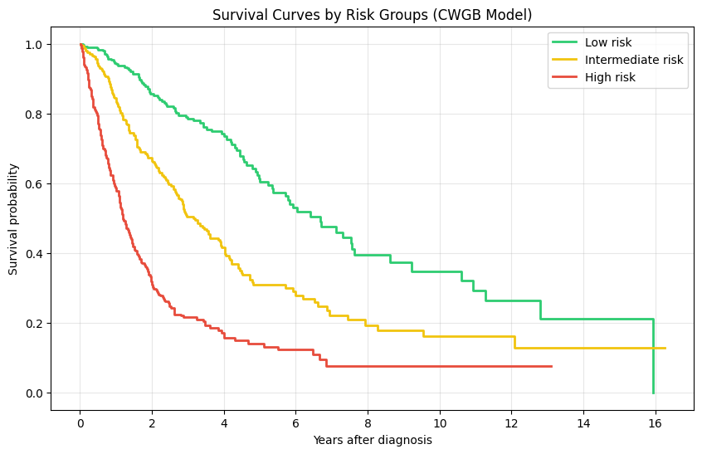

- REFERENCES

[1] David G. Kleinbaum and Mitchel Klein (2012), Survival Analysis: A Self-Learning Text, Springer.
[2]: Peter L. Greenberg, Heinz Tuechler, Julie Schanz, Guillermo Sanz, Guillermo Garcia-Manero, Francesc Solé, John M. Bennett, David Bowen, Pierre Fenaux, Francois Dreyfus, Hagop Kantarjian, Andrea Kuendgen, Alessandro Levis, Luca Malcovati, Mario Cazzola, Jaroslav Cermak, Christa Fonatsch, Michelle M. Le Beau, Marilyn L. Slovak, Otto Krieger, Michael Luebbert, Jaroslaw Maciejewski, Silvia M. M. Magalhaes, Yasushi Miyazaki, Michael Pfeilstöcker, Mikkael Sekeres, Wolfgang R. Sperr, Reinhard Stauder, Sudhir Tauro, Peter Valent, Teresa Vallespi, Arjan A. van de Loosdrecht, Ulrich Germing, Detlef Haase; Revised International Prognostic Scoring System for Myelodysplastic Syndromes. Blood 2012; 120 (12): 2454–2465.
[3] Döhner et al., "Diagnosis and Management of AML in Adults: 2022 ELN Recommendations" Blood, 2022, Vol. 140, No. 12 DOI: 10.1182/blood.2022016867
[4] Bejar et al., New England Journal of Medicine, 2011 "Clinical Effect of Point Mutations in Myelodysplastic Syndromes" DOI: 10.1056/NEJMoa1013343
[5] Scikit Survival Documentation https://scikit-survival.readthedocs.io/en/stable/user_guide/understanding_predictions.html
[6] Pycox documentation https://github.com/havakv/pycox
[7] Katzman, J. L., Shaham, U., Cloninger, A., Bates, J., Jiang, T., & Kluger, Y. (2018). DeepSurv: personalized treatment recommender system using a Cox proportional hazards deep neural network. *BMC Medical Research Methodology

ANNEXE 1: EXPLORATORY ANALYSIS
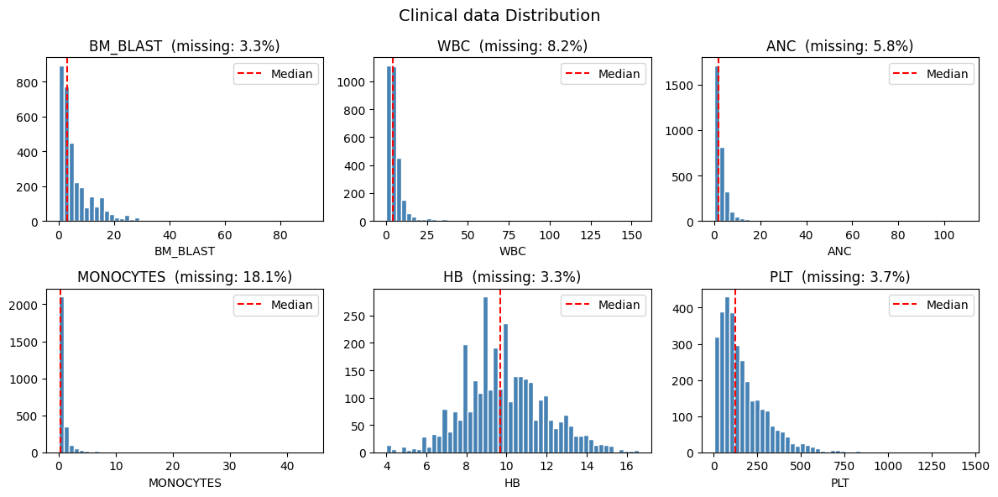
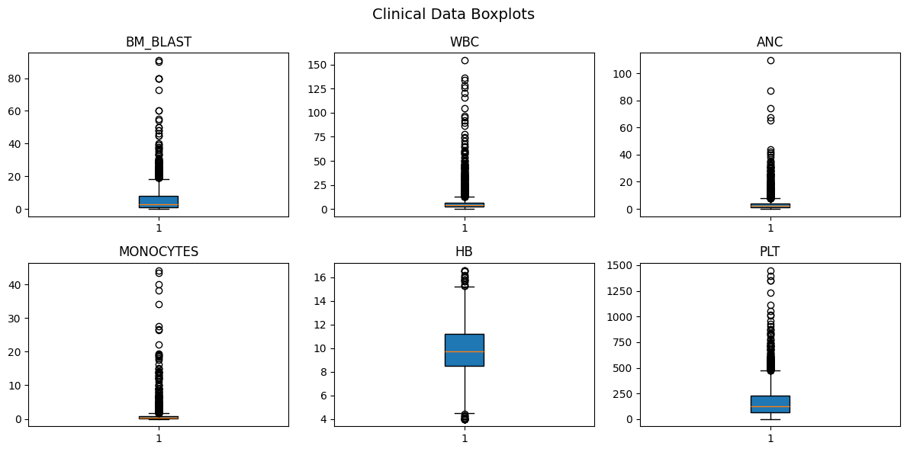
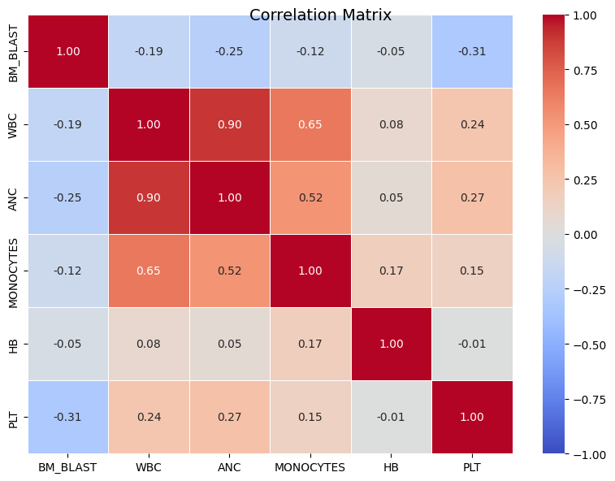
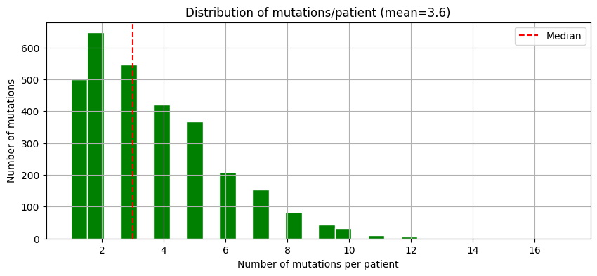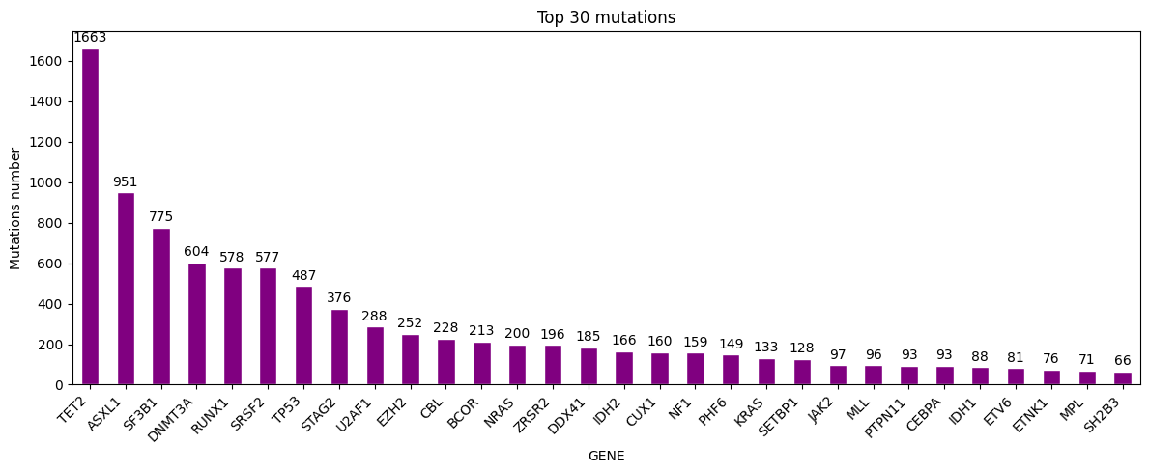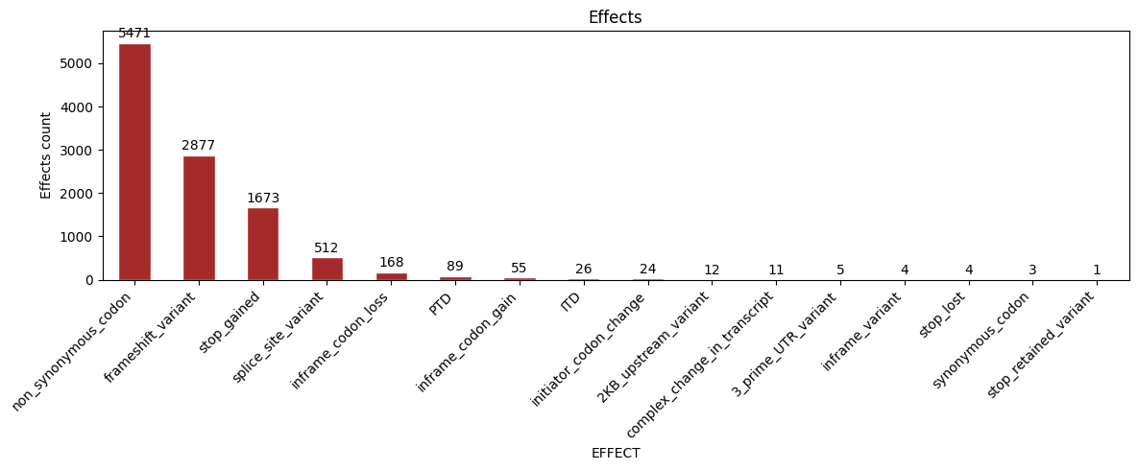
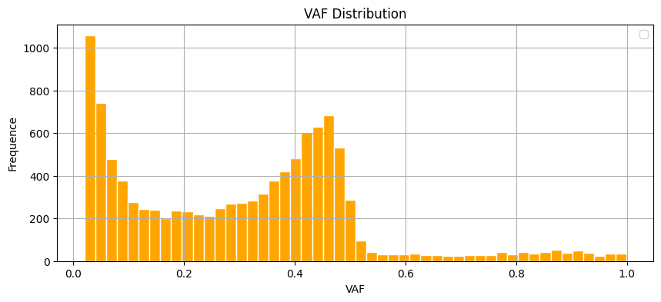
ANNEXE 2: SURVIVAL ANALYSIS
3 Events (Relapse, Progression, Death)
Survival time = time between ‘response to treatment’ and event. (usually time to death or relapse-free survival time)
Censored observations = no data: patient has not experienced (yet) the event, or lost follow-up
The survival probability (survivor function) S(t) is the probability that an individual survives from the time origin (e.g. diagnosis of cancer) to a specified future time t.
The hazard h(t) is the probability that an individual who is under observation at a time t has an event at that time.

- Kaplan-Meier plots to visualize survival curves
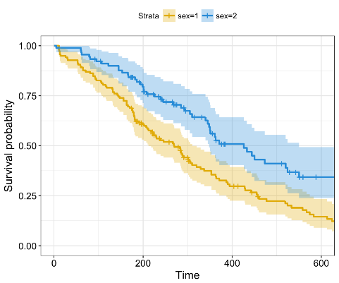
Two R packages: survival for computing survival analyses, survminer for summarizing and visualizing the results of survival analysis.
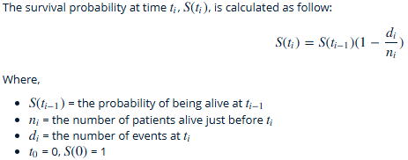

- Log-rank test to compare the survival curves of two or more groups
The log-rank test is a non-parametric test comparing the observed number of events in each group to what would be expected if the null hypothesis were true (i.e., if the survival curves were identical). Its statistic is approximately distributed as a chi-square test statistic. (survdiff() in R)

- Cox proportional hazards regression to describe the effect of variables on survival.
KM and Log Rank works well for Univariate analysis (ignore the impact of others factors)
Cox proportional hazards regression analysis works for both quantitative predictor variables and for categorical variables. Furthermore, it extends survival analysis methods to assess simultaneously the effect of several risk factors on survival time.
Exp(bi) are the Hazard Ratios (HR = 1: No effect, HR < 1: Reduction in the hazard, HR > 1: Increase in Hazard)

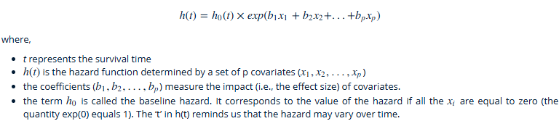


Model hypothesis:
- Hazard Ratio proportional (independent of time), can be tested by Schoenfeld Residue Test
- Log Linearity: Each variable impact is linear on the risk log. Test with Martingale Residue
- Observation independence: a patient survival does not impact another one. Ex: Use of a Stratified Cox to have a basis risk different by center

